Rectangle of perimeter L m. Find in terms of L:
[a] The maximum area.
l

w

2w + 2l = L → l = $\frac{L – 2w}{2}$
A = lw = ($\frac{L – 2w}{2}$)w

[b] The dimensions.
A’ = $\frac{–4x + y}{2}$ → A’ = 0 → w = $\frac{L}{4}$
l = $\frac{L – 2(\frac{L}{4})}{2}$ = $\frac{L}{2}$ x $\frac{1}{2}$ = $\frac{L}{4}$

A triangle has one side twice as long as the other, the third being replaced with a sufficiently long straight wall.
[a] Determine the maximum area, in terms of L. You don’t necessarily have to use calculus techniques but be sure to state your reasoning.
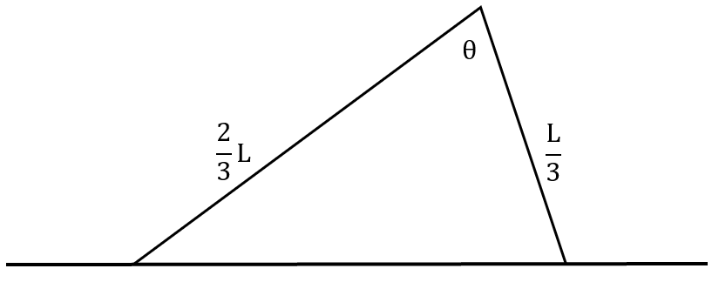
Let ‘A’ represent area.
A = $\frac{1}{2}$($\frac{2}{3}L$)($\frac{L}{3}$)sinθ = $\frac{2L^{2}}{18}$sinθ = $\frac{L^{2}}{9}$sinθ
$\frac{dA}{dθ}$ = $\frac{L^{2}}{9}$cosθ → A’ = 0 → θ = $\frac{π}{2}$ (0<θ<π)
A = $\frac{L^{2}}{9}$sin($\frac{π}{2}$) = $\frac{L^{2}}{9}$

[b] Determine what would happen if the sides had no restrictions. Use calculus.
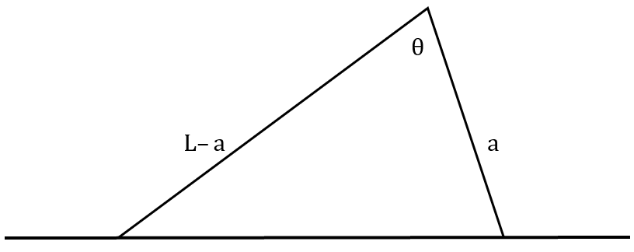
Let ‘A’ represent area.
A = $\frac{1}{2}$(L–a)(a)sinθ = $\frac{La–a^{2}}{2}$sinθ
$\frac{dA}{dθ}$ = $\frac{La – a^{2}}{2}$cosθ → A’ = 0 → θ = $\frac{π}{2}$ (0<θ<π)
A = $\frac{La – a^{2}}{2}$sin($\frac{π}{2}$) = $\frac{La – a^{2}}{2}$
$\frac{dA}{da}$ = $\frac{–2a + L}{2}$ → A’ = 0 → a = $\frac{L}{2}$
A = $\frac{1}{2}$(L–a)(a) = $\frac{1}{2}$(L – $\frac{L}{2}$)($\frac{L}{2}$) = $\frac{1}{2}$($\frac{L}{2}$)² = $\frac{1}{2}$ x $\frac{L^{2}}{4}$ = $\frac{L^{2}}{8}$

